Internship task-2

**Task 1: Set up AWS Organizations for managing multiple AWS accounts.**

# Step1- Open AWS Organizations from the AWS Management Console.

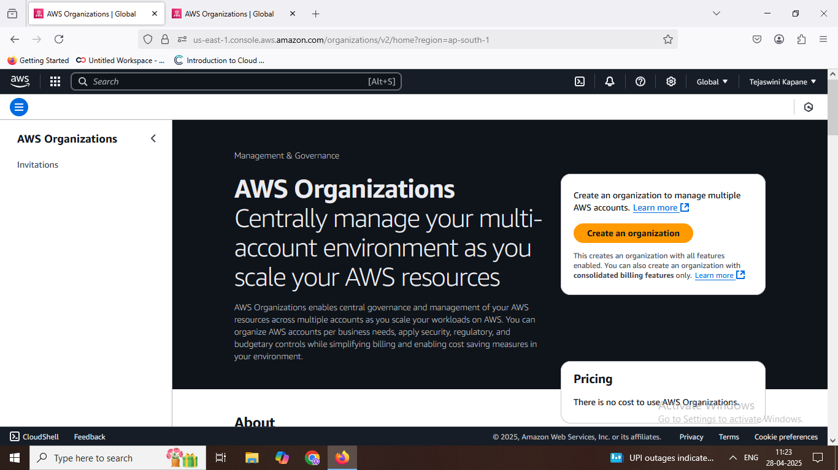

**Step2- Add an AWS account to the Organization**

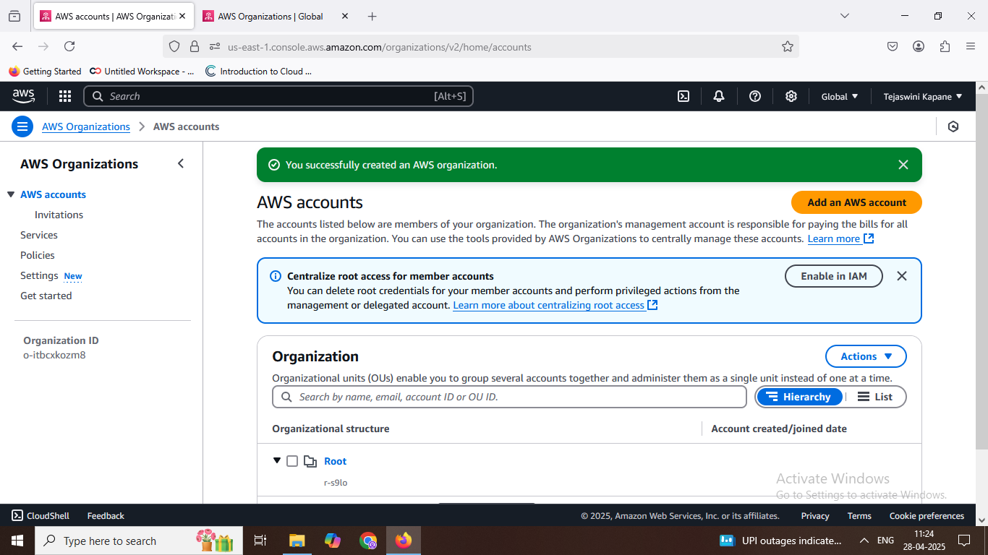

**Step3- Enter the AWS account details.**

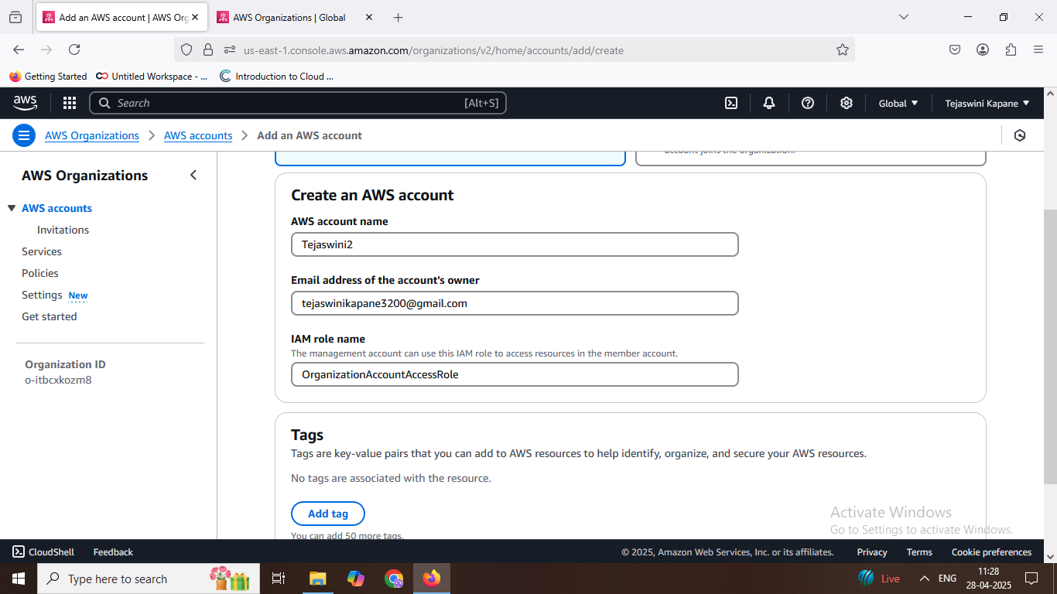

**Step 4- Create one or more AWS accounts within your organization.**

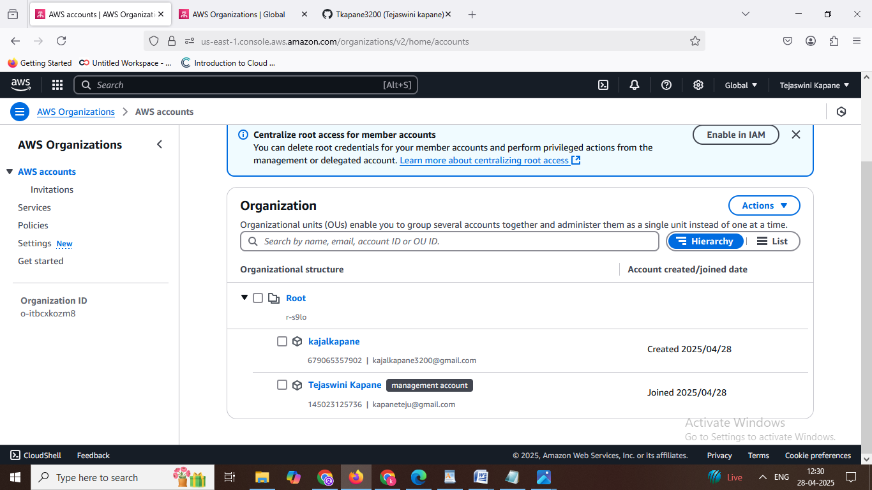

**Step5- Verify your AWS account by checking the confirmation email.**

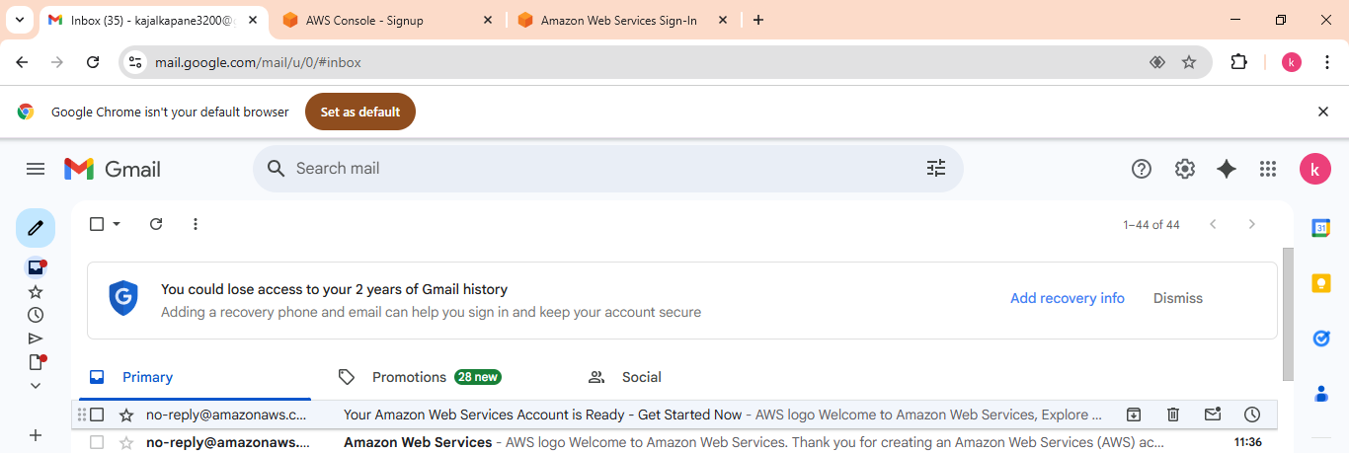

**Task 2: What is the purpose of use of AWS-CLI? What are the key requirements to access AWS account using AWS-CLI.**

**Create a working custom VPC. Launch one server in each subnet & connect private server with bastion host using CLI.**

**Step1: Install the AWS CLI.**

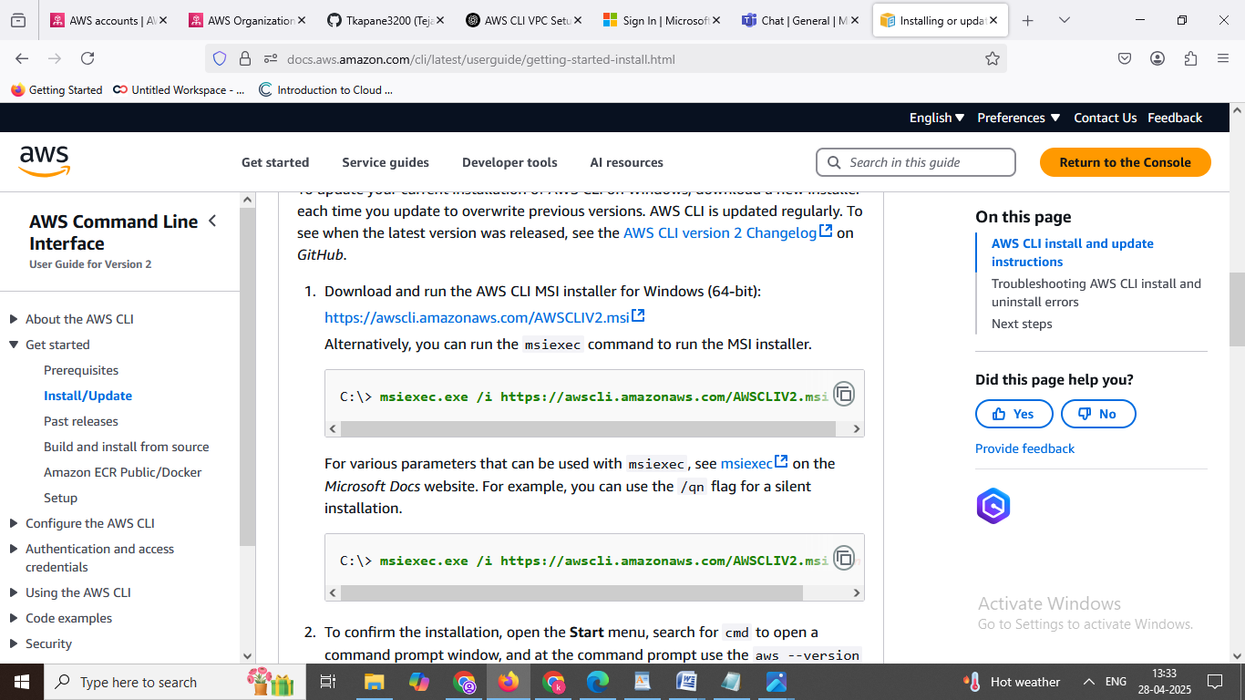

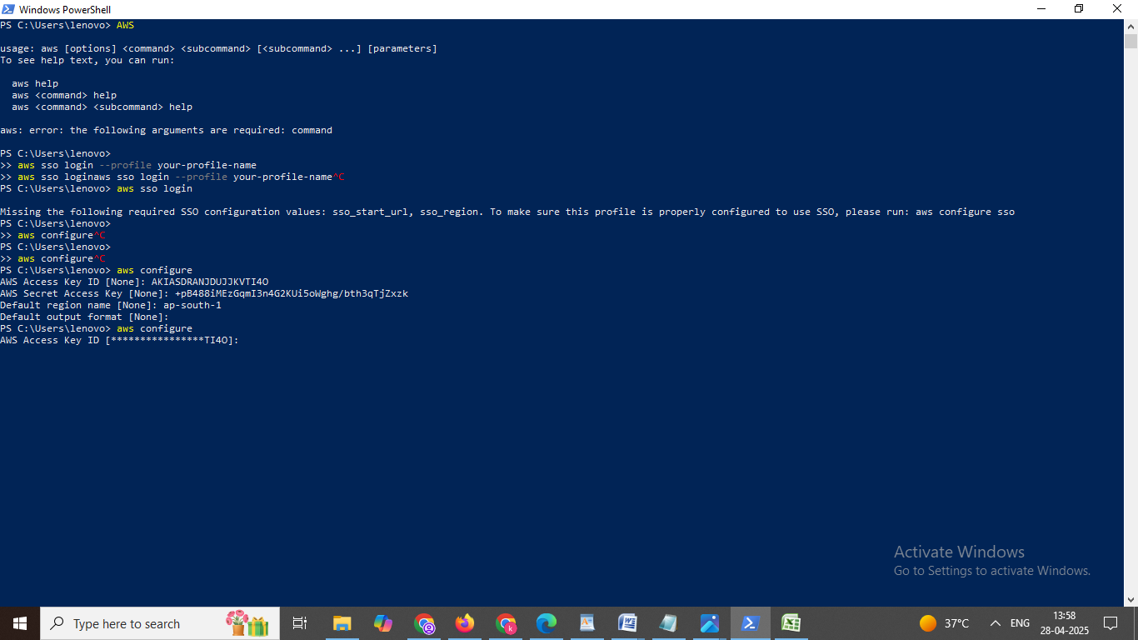**Step2: Configure AWS CLI.**

**Step3: Create a Custom VPC.**

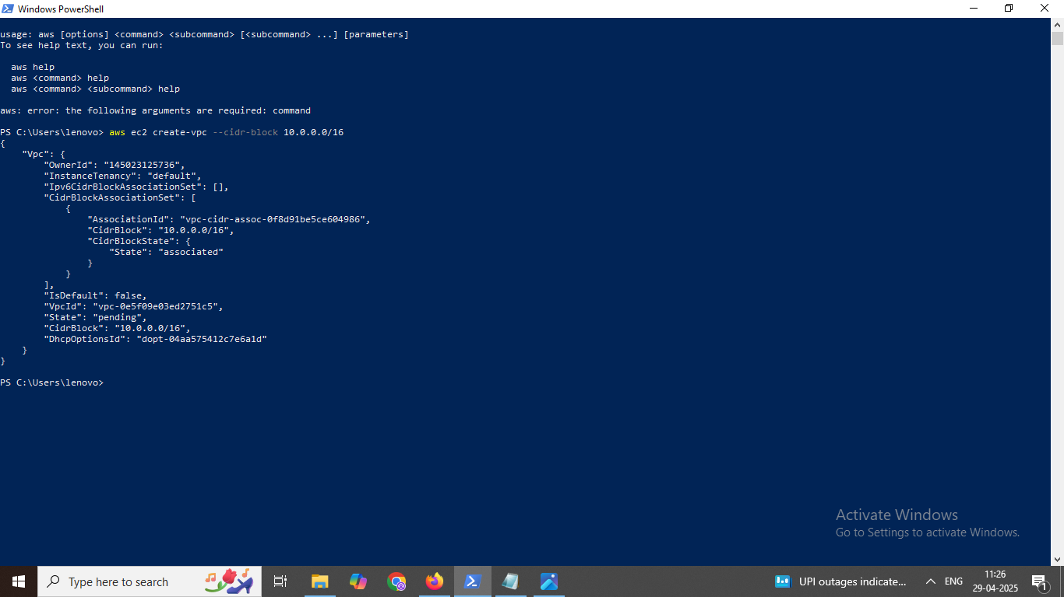

**Step4: Create a public Subnet.**

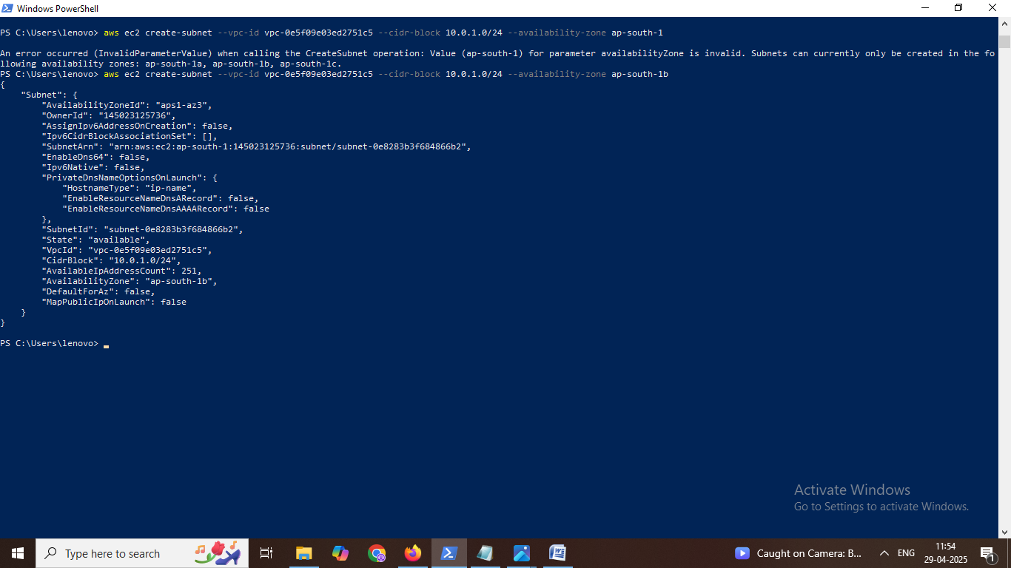

**Step5: Create internet gateway.**

{

"InternetGateway": {

"Attachments": [],

"InternetGatewayId": "igw-076a4db167bb3ff1e",

"OwnerId": "145023125736",

"Tags": []

}

}

**Step6:Attach the internet gateway to the vpc.**

aws ec2 attach-internet-gateway --internet-gateway-id igw-076a4db167bb3ff1e --vpc-id vpc-0e5f09e03ed2751c5

**Step7:Create a route table.**

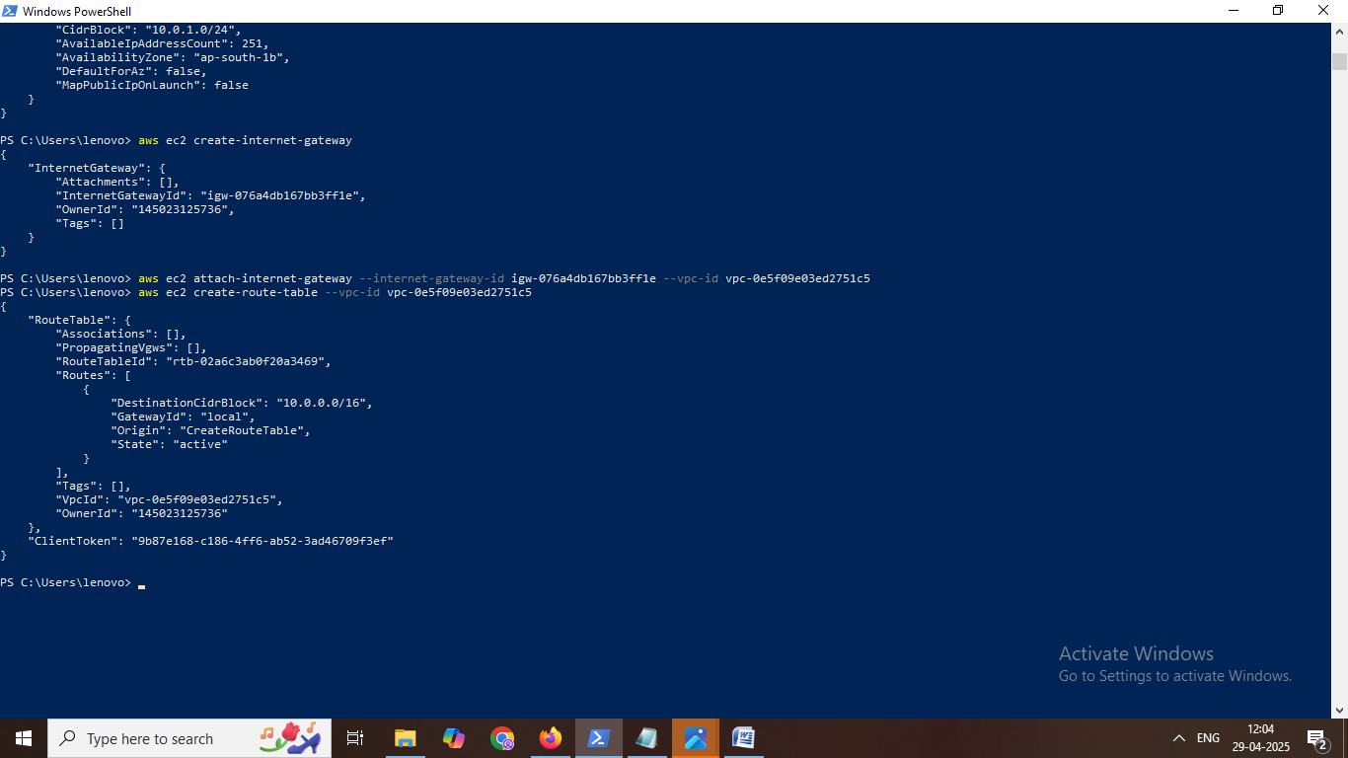

**Step8: Add a route to the internet.**

aws ec2 create-route --route-table-id rtb-02a6c3ab0f20a3469 --destination-cidr-block 0.0.0.0/0 --gateway-id igw-076a4db167bb3ff1e

{

"Return": true

}

Step9: Associate the route table with the public subnet.

aws ec2 associate-route-table --subnet-id subnet-0e8283b3f684866b2 --route-table-id rtb-02a6c3ab0f20a3469

{

"AssociationId": "rtbassoc-0d2f9135d5947e623",

"AssociationState": {

"State": "associated"

}

}

**Step10: Create a key pair for ssh access.**

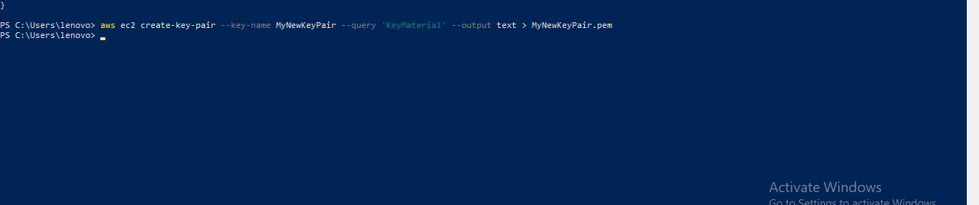

**Step11: Set proper key permissions for windows.**

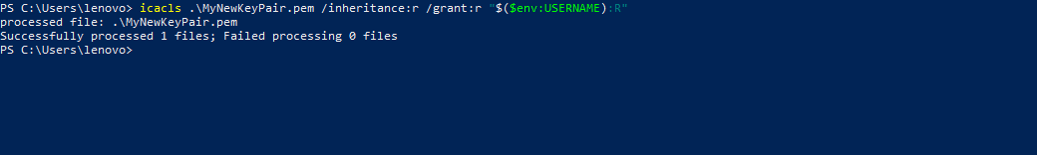

**Step12: Find image id (ami Id).**

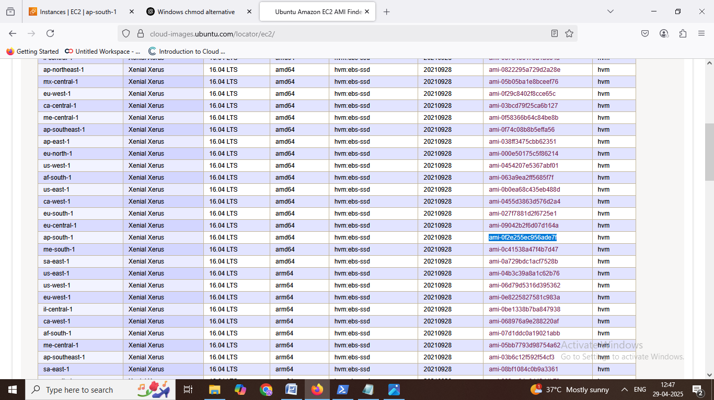

**Step12: Launch a bastion host in the public subnet.**

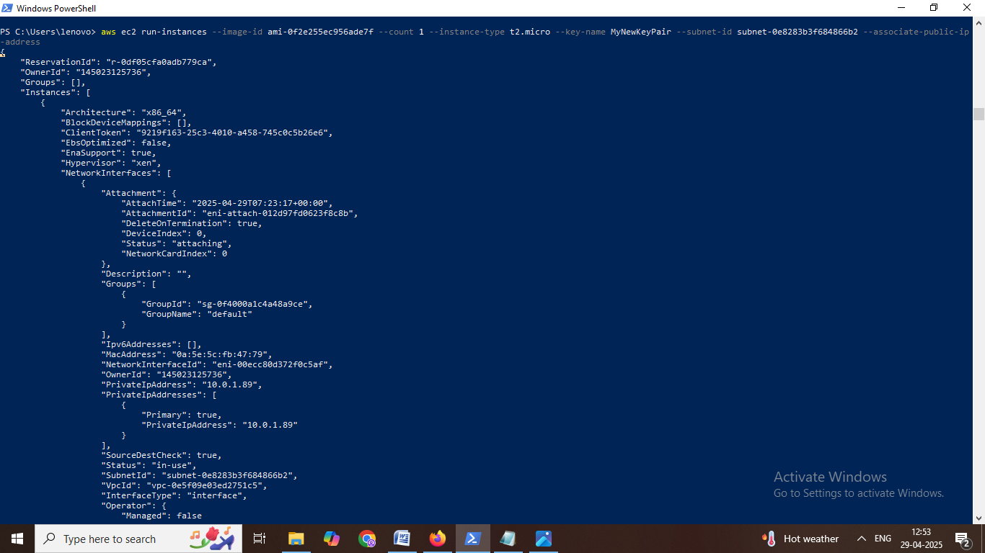

**Step13: Launch a private server in the private subnet.**

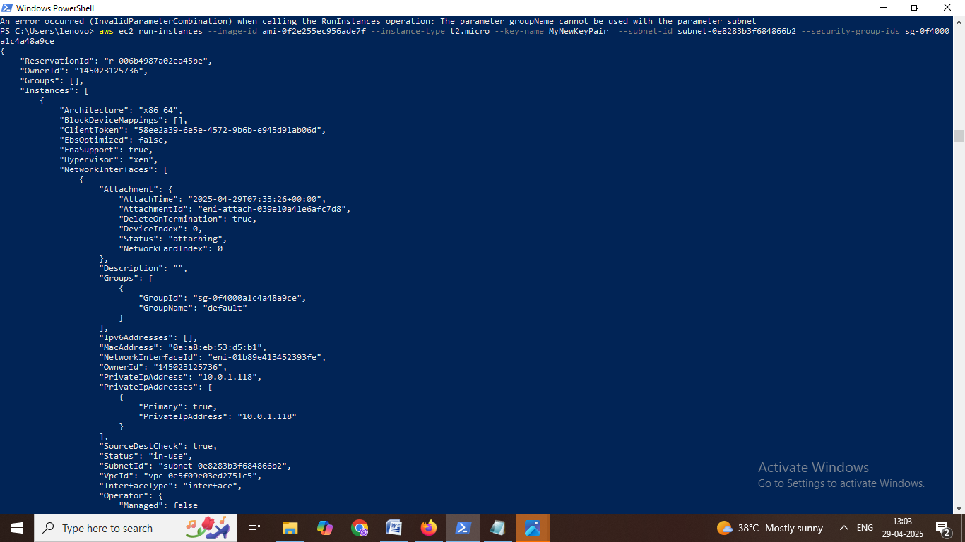

**Step: Verify the instances are running.**

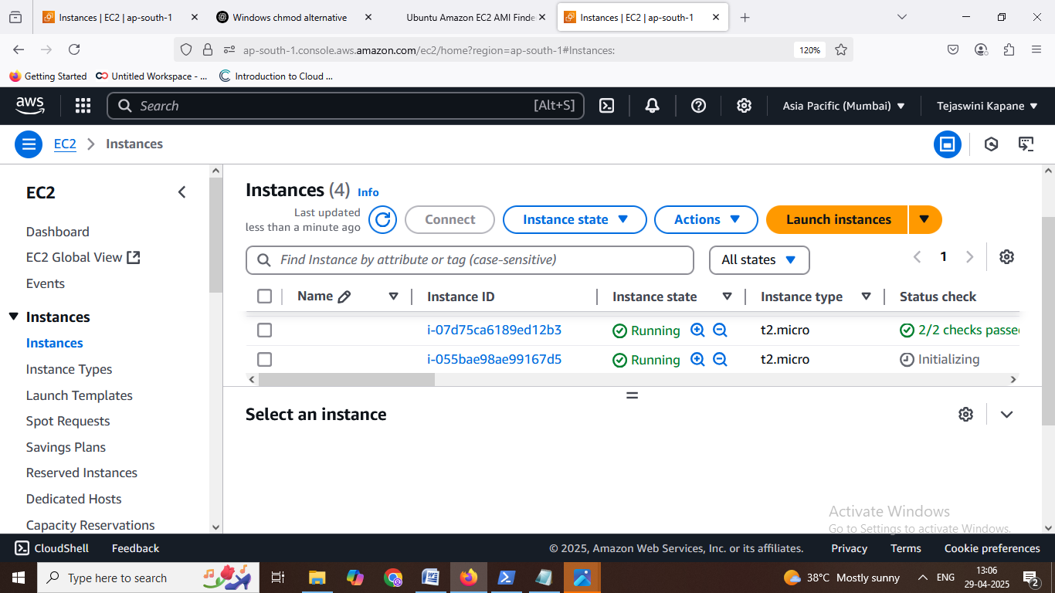

**Task 3: Write a short note on S3. What is difference between Static website and Dynamic website?**

**Create a static website using S3 with minimum 3 pages having images and videos.**

1. **Write a short note on S3.**

Ans :Amazon S3 (Simple Storage Service) is a scalable, high-speed, web-based cloud storage service offered by Amazon Web Services (AWS). It is designed to store and retrieve any amount of data from anywhere on the web. S3 is commonly used for data backup, archival, content distribution, static website hosting, and application data storage.

Key features of S3 include:

1) Object storage: Data is stored as objects within buckets.

2) Durability: Offers 99.999999999% (11 nines) durability by automatically replicating data across multiple facilities.

3) Scalability: Automatically scales to handle growing amounts of data and high traffic.

4) Security: Provides features like encryption, access control policies, and integration with AWS Identity and Access Management (IAM).

5) Cost-effective: Pay-as-you-go pricing with different storage classes for varying access needs.

1. **What is difference between Static website and Dynamic website.**

### **i) Static Website:**

**1) Content** is fixed and delivered exactly as stored.

2) Built using **HTML, CSS, and sometimes JavaScript**.

3) Each page is a separate file on the server.

**4) No server-side processing**—the browser displays the same content for all users.

**5) Faster and more secure**, suitable for simple sites like portfolios or documentation.

ii) Dynamic Website:

1) Content is generated in real-time based on user interactions or data from databases.

2) Uses server-side technologies like PHP, Python, Node.js, or frameworks like Django or Laravel.

3) Personalized and interactive—users may see different content based on login status, preferences, etc.

4) Requires a database (like MySQL or MongoDB)

C) **Create a static website using S3 with minimum 3 pages having images and videos.**

**Step1: This application contains 3 pages, each including images and a video**.

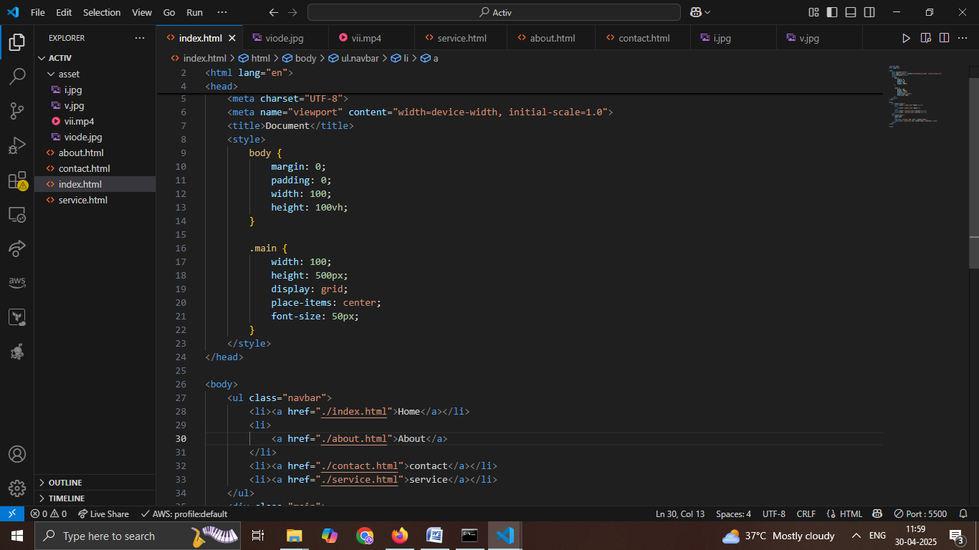

**Step2: About page of the static website, displaying an image and an embedded video.**

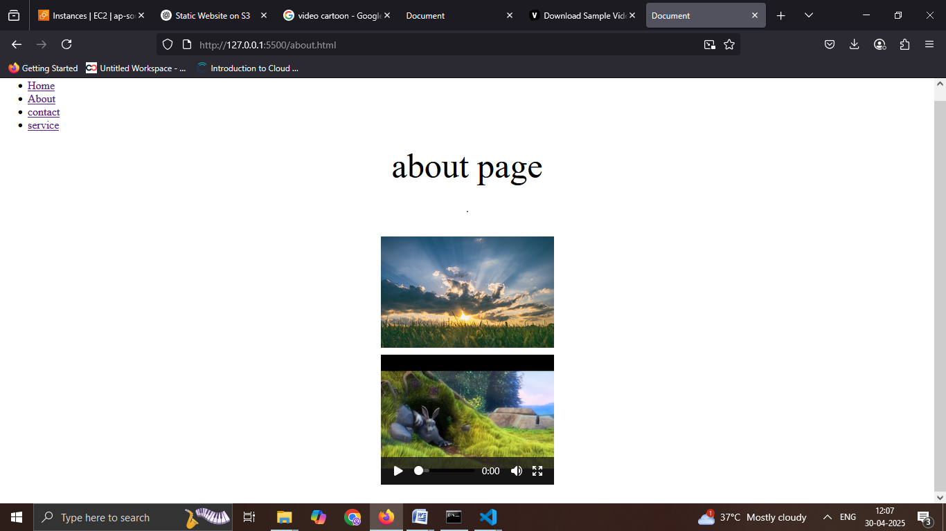

**Step3: Creating a new S3 bucket in the AWS Management Console for hosting the static website.**

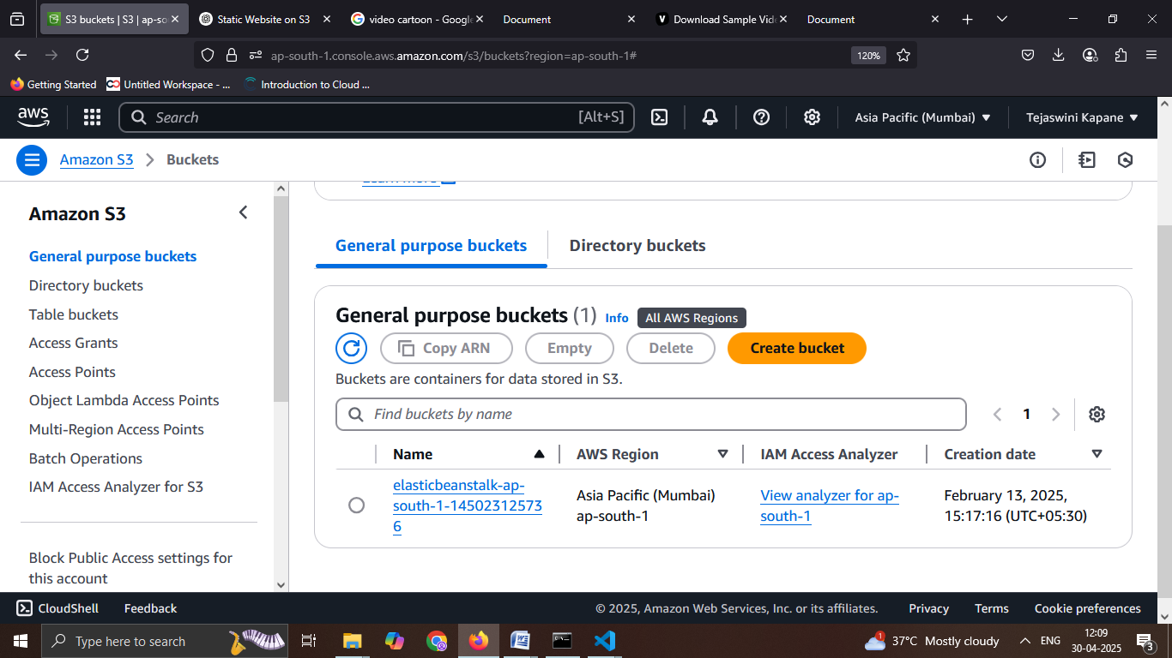

**Step4: Configuring Object Ownership settings while creating the S3 bucket. "ACLs enabled" is selected to allow object access control via access control lists (ACLs).**

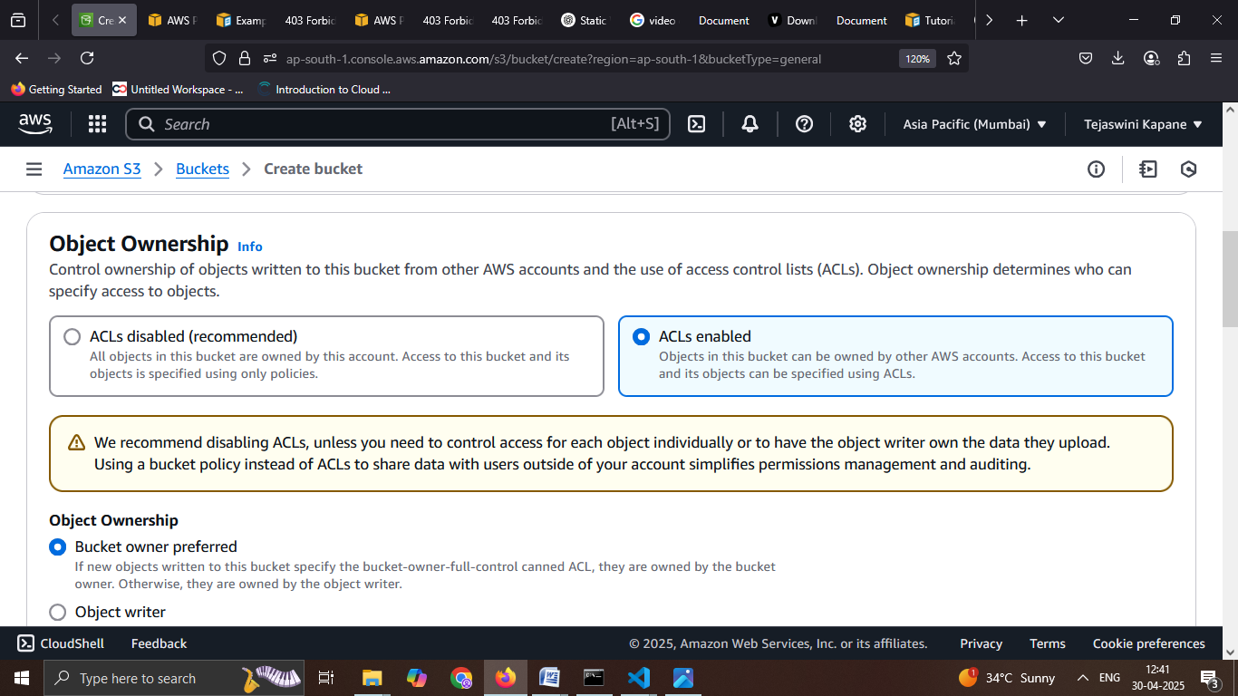

**Step5: Confirmation message showing successful creation of the S3 bucket named "mywebsiteteju" in the AWS S3 console**

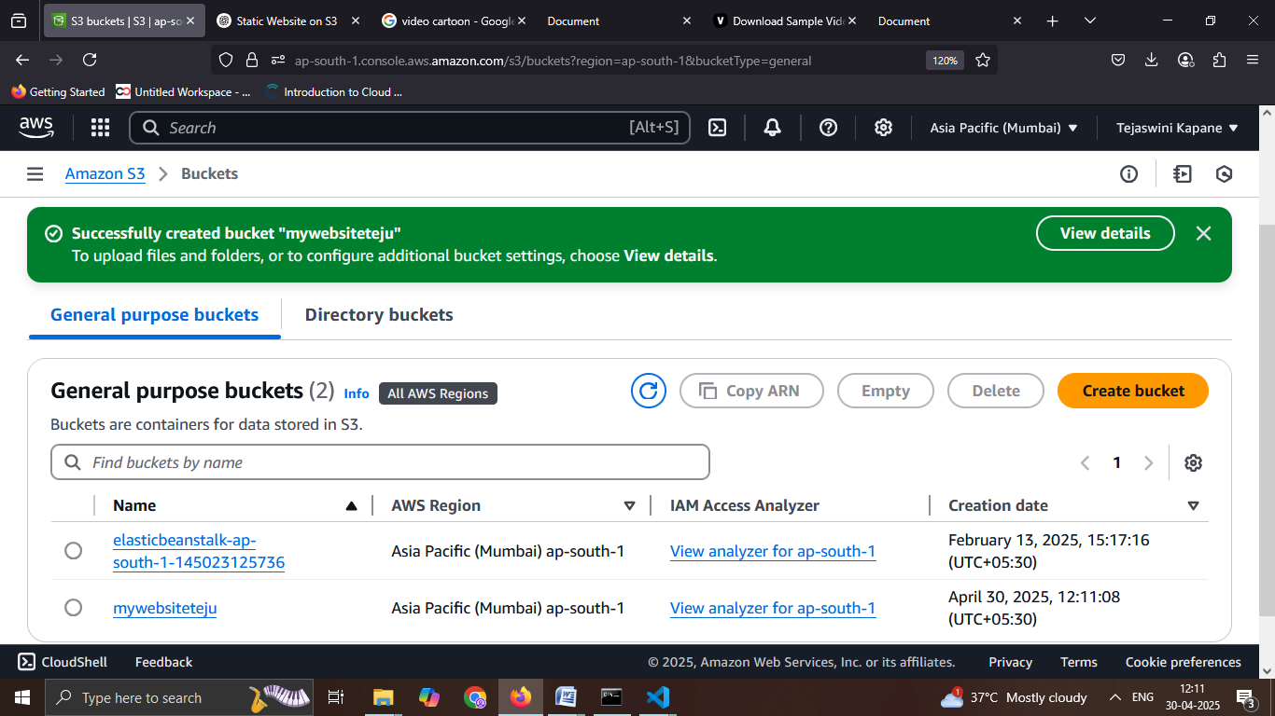

**Step6: Files and folders successfully uploaded to the S3 bucket "mywebsiteteju" with confirmation of upload status.**

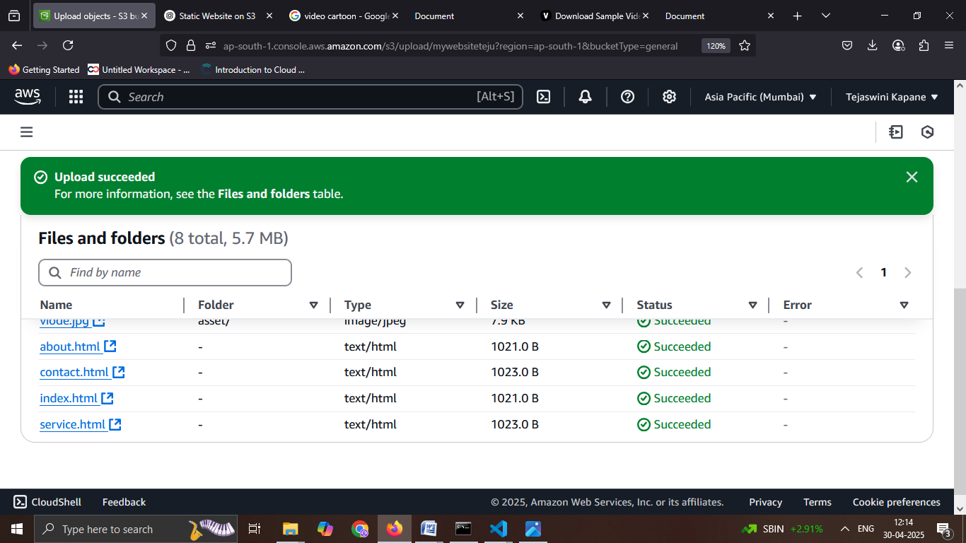

**Step7: Static website hosting option displayed for the S3 bucket "mywebsiteteju" before enabling hosting.**

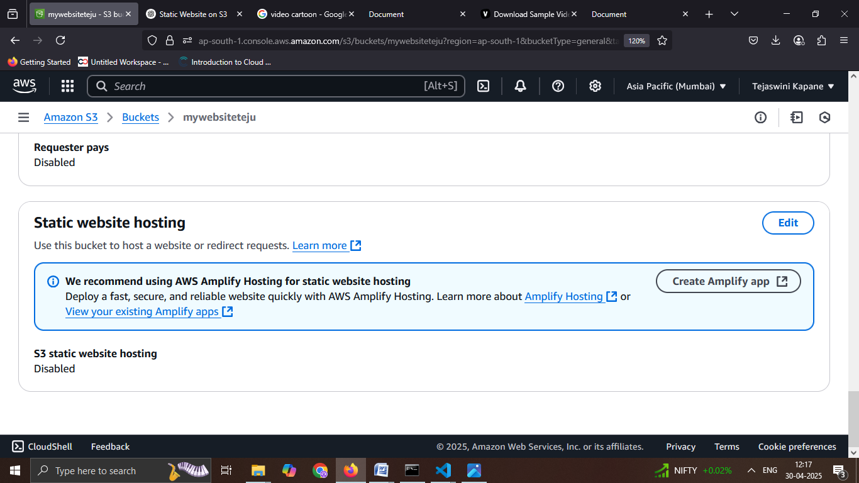

**Step8: Confirmation of successfully enabling static website hosting for the S3 bucket "mywebsiteteju".**

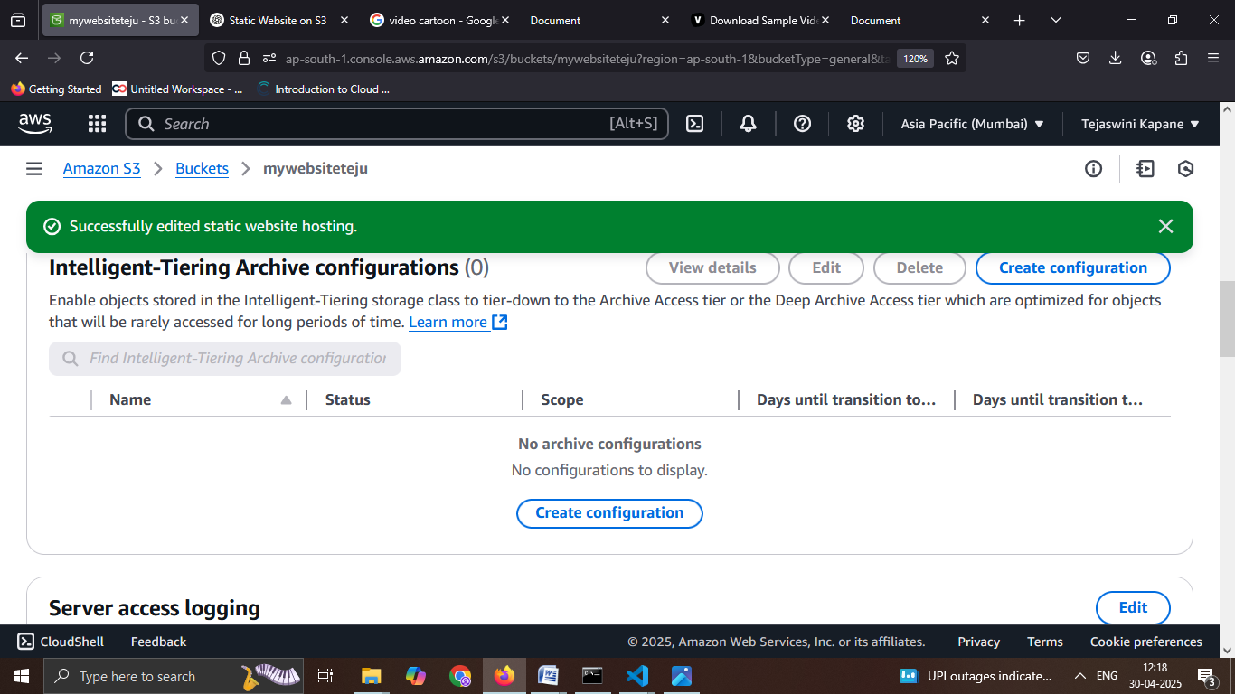

**Step 9: S3 bucket public access settings showing that "Block all public access" is enabled this must be turned off to allow public website access.**

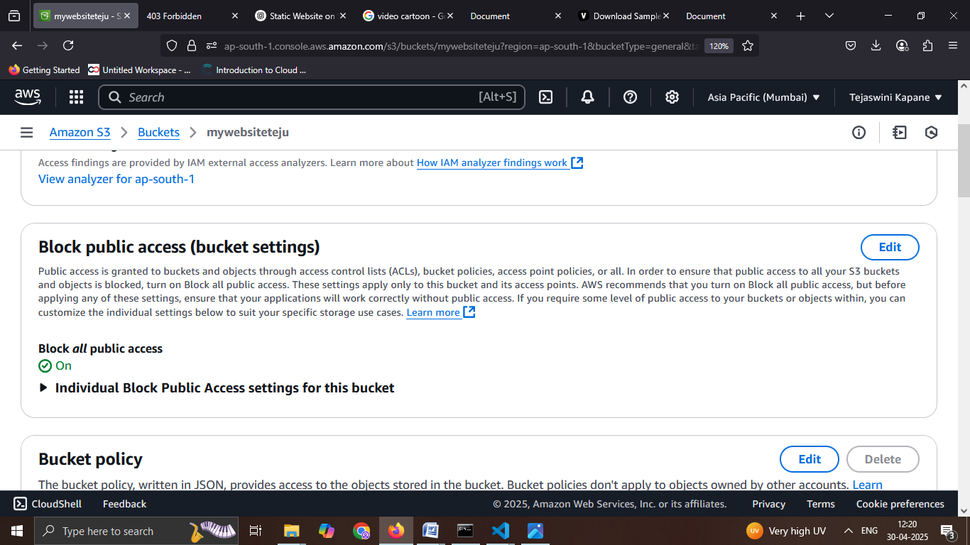

**Step10: Successfully edited the public access settings for the S3 bucket in the AWS Management Console. No objects failed to update.**

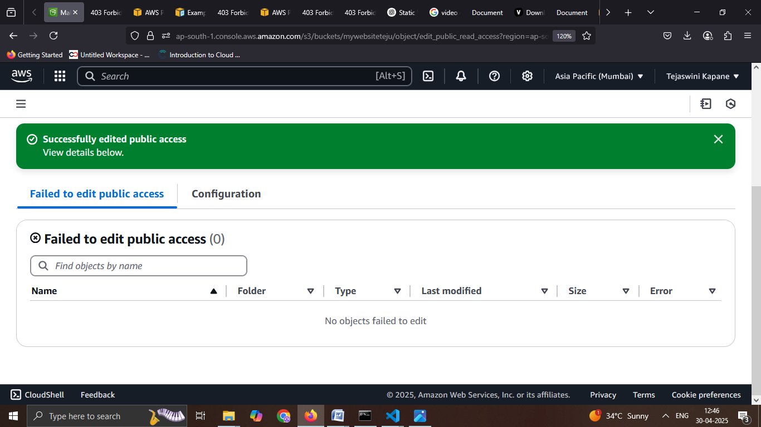

**Step11: Successfully hosted and accessed the S3 static website with working navigation, images, and video content using Amazon S3**.

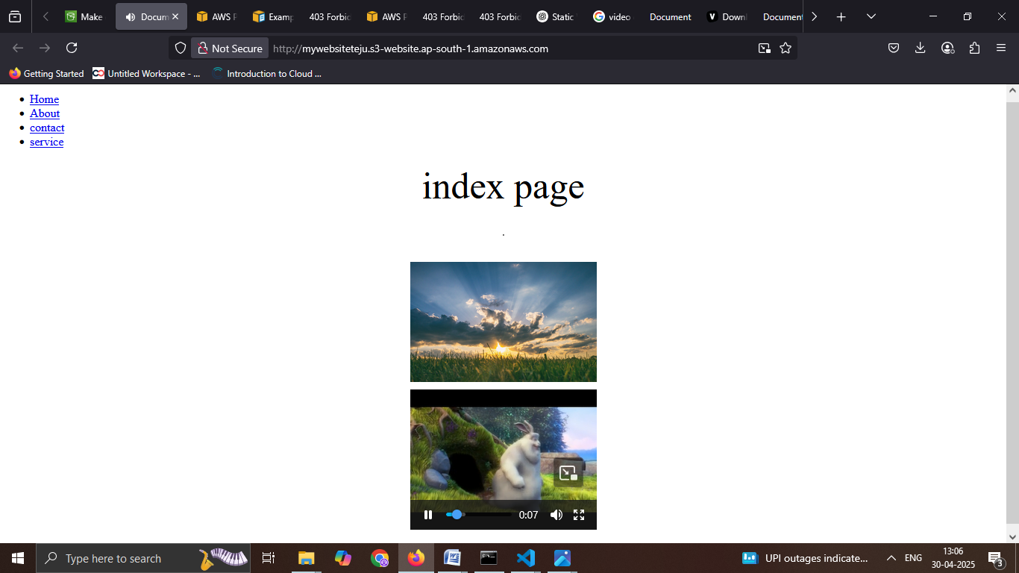

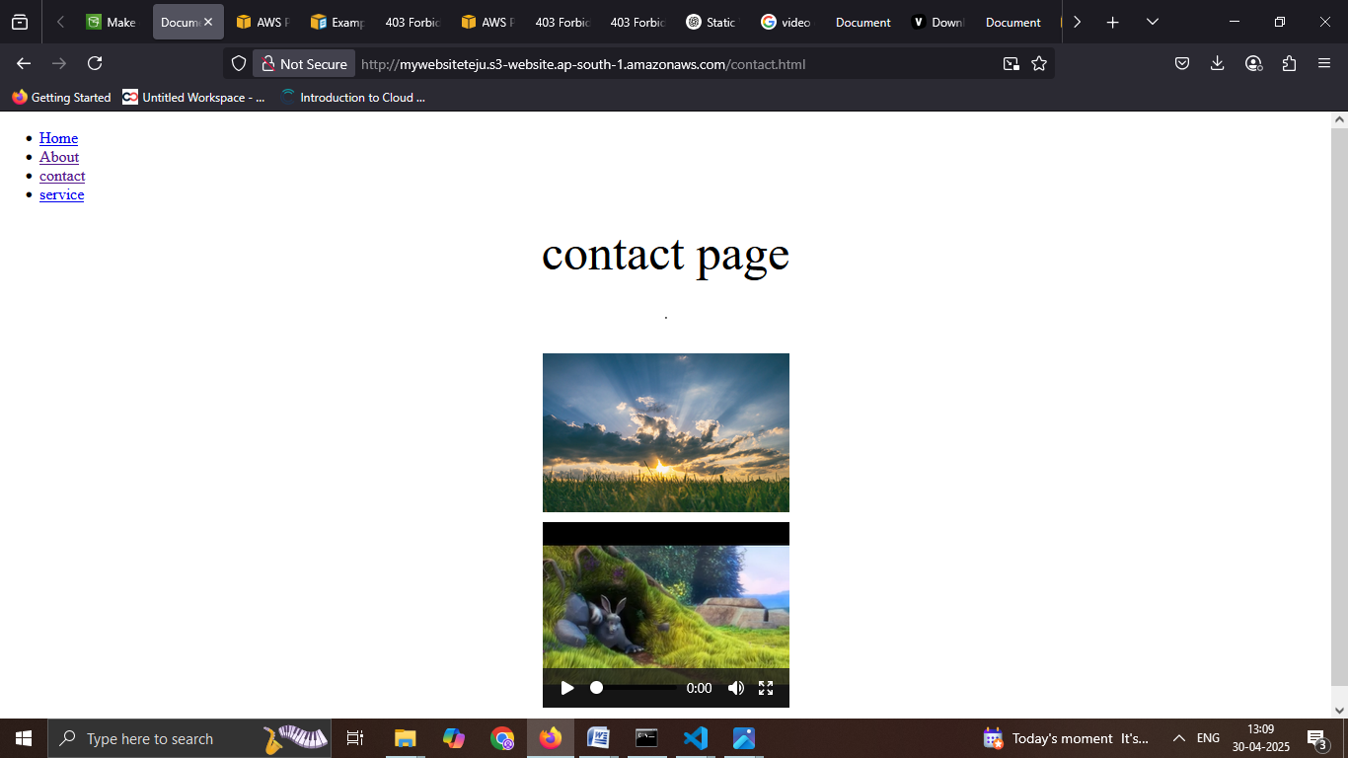

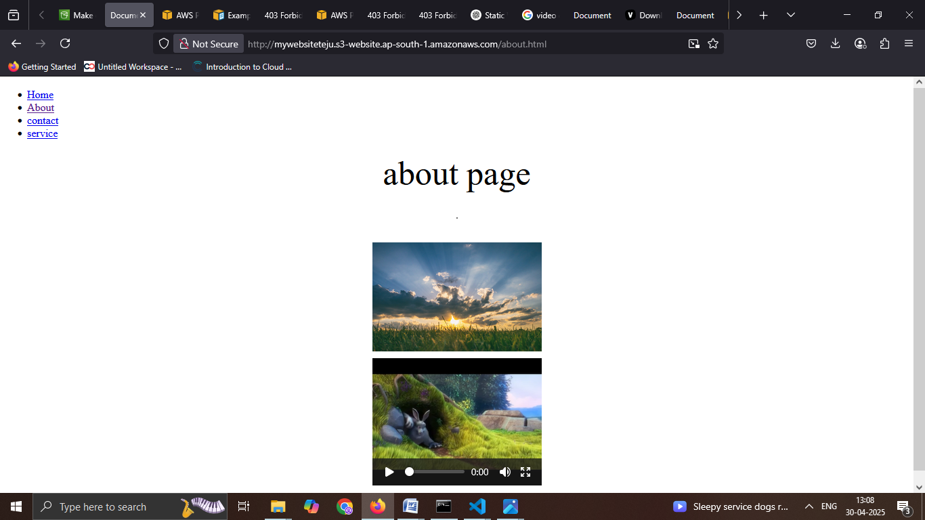

**Task 4: Create a architectural diagram of uses of cloud front.**

User

Bucket with static content

Instances

Load balancer

Amazon cloud front

Amazon route 53

• **Low latency** through caching (CloudFront + S3)

• **High availability and scalability** (via Load Balancer and EC2)

• **Efficient routing** (with Route 53)

• **Cost optimization** (by reducing load on backend resources)

**Task 5: What is Instance Refresh? Demonstrate the use of Instance Refresh.**

**Or**

**Company is using an application running on Apache with auto scaling server and now they want to use Nginx web server with auto scaling. Now Company want to use newer version of application without downtime.**

**Maximum capacity of server- 4**

**Minimum capacity of server- 2**

1. **What is Instance Refresh**

Ans: Instance Refresh is a process that automatically updates the instances within an Auto Scaling Group, allowing you to replace instances without manual intervention. This is particularly useful when you need to deploy a new Amazon Machine Image (AMI), user data script, or launch template across a group of instances.

1. **Company is using an application running on Apache with auto scaling server and now they want to use Nginx web server with auto scaling. Now Company want to use newer version of application without downtime.**

**Maximum capacity of server- 4**

**Minimum capacity of server- 2**

## Step1: AWS VPC Console showing existing VPCs and the option to create a new VPC.

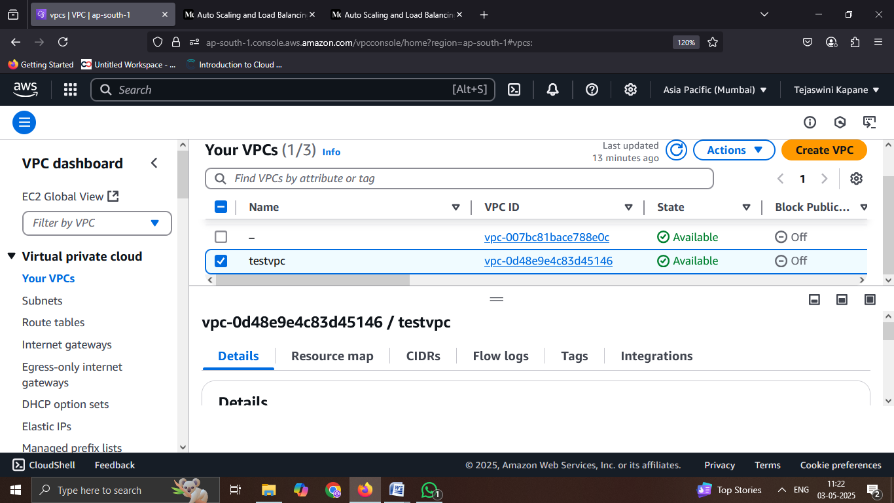

## Step2: AWS Subnets Console displaying three created public subnets within the selected VPC.

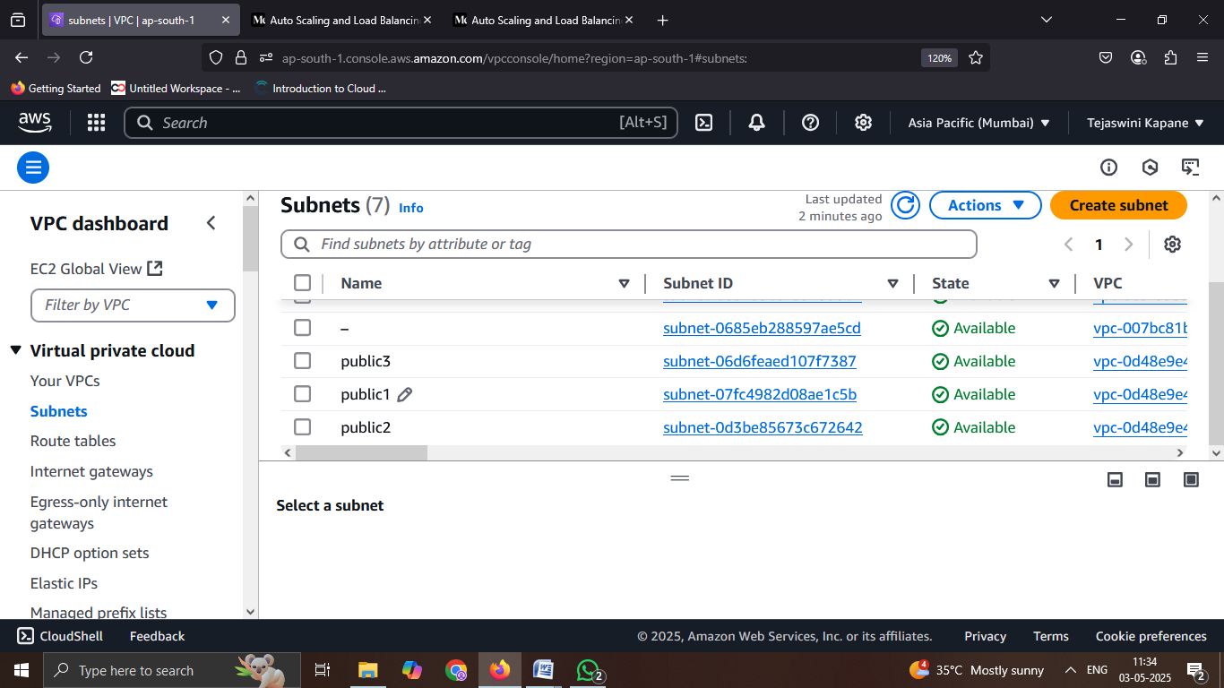

**Step3:** **Successfully created Internet Gateway in AWS with the option to attach it to a VPC.**

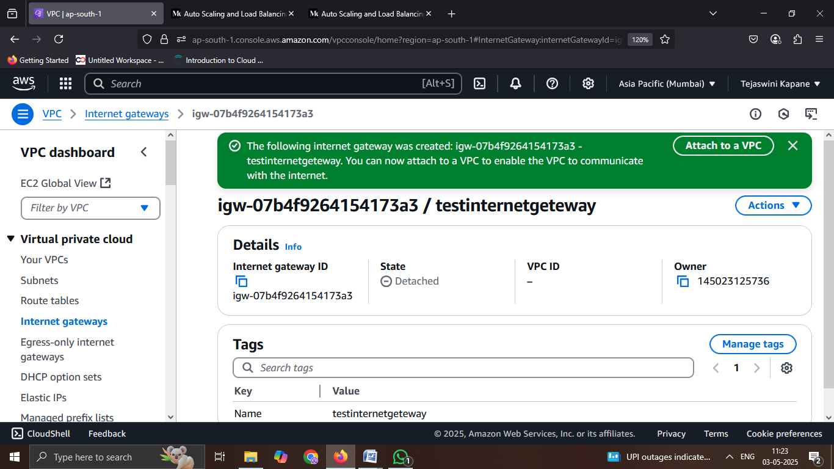

**Step4:** **Internet Gateway successfully attached to the selected VPC and associated subnets in AWS VPC Dashboard.**

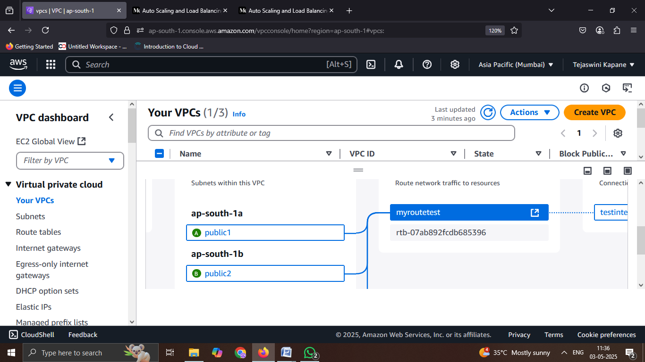

**Step5: Target Group 'mytargettest' successfully created in the AWS EC2 Dashboard with HTTP protocol and no associated load balancer.**

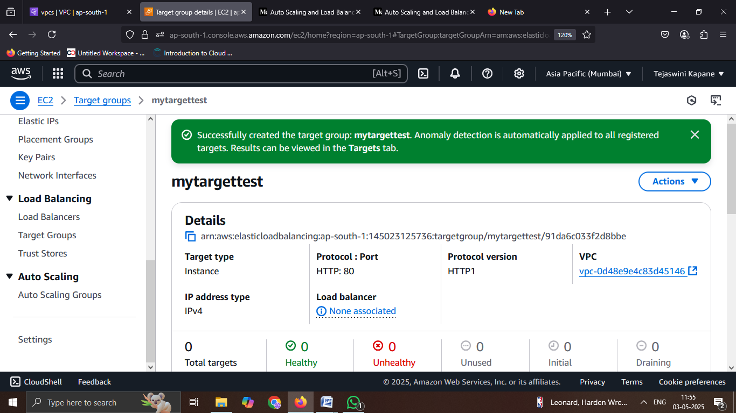

**Step6: Load Balancer 'myloadbalancetest' successfully created with an Internet-facing scheme and provisioning status in the AWS EC2 Dashboard.**

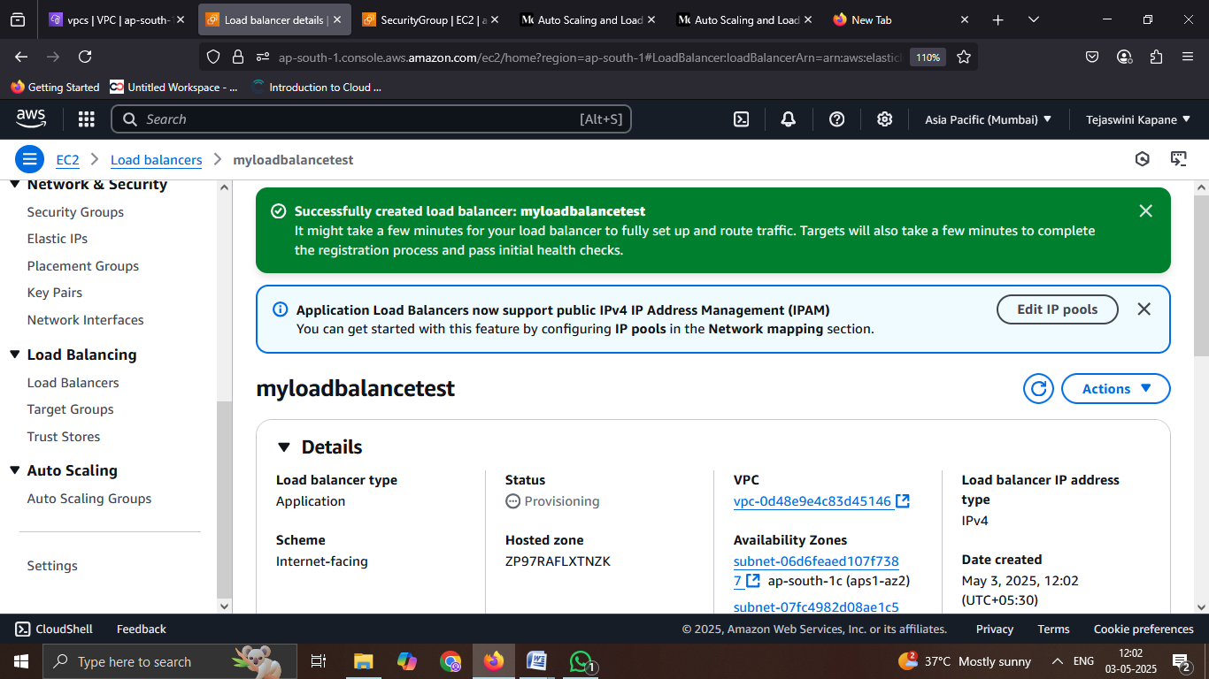

**Step7: Initial screen for creating an Auto Scaling Group in the AWS EC2 Dashboard.**

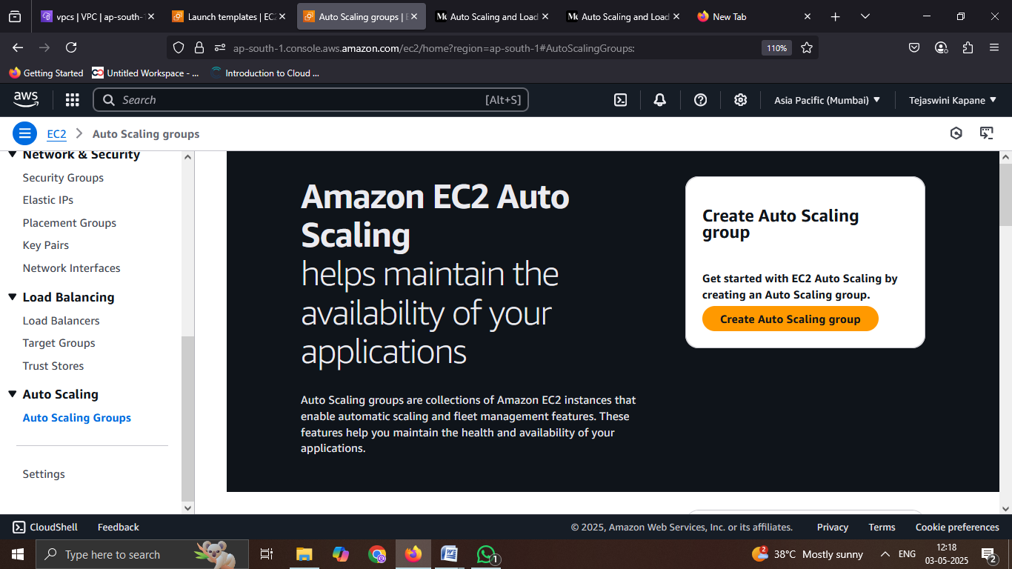

**Step8: Configuring an Auto Scaling group with a desired capacity of 3 instances, minimum capacity of 3, and maximum capacity of 4 in the AWS EC2 console, with no scaling policies selected**.

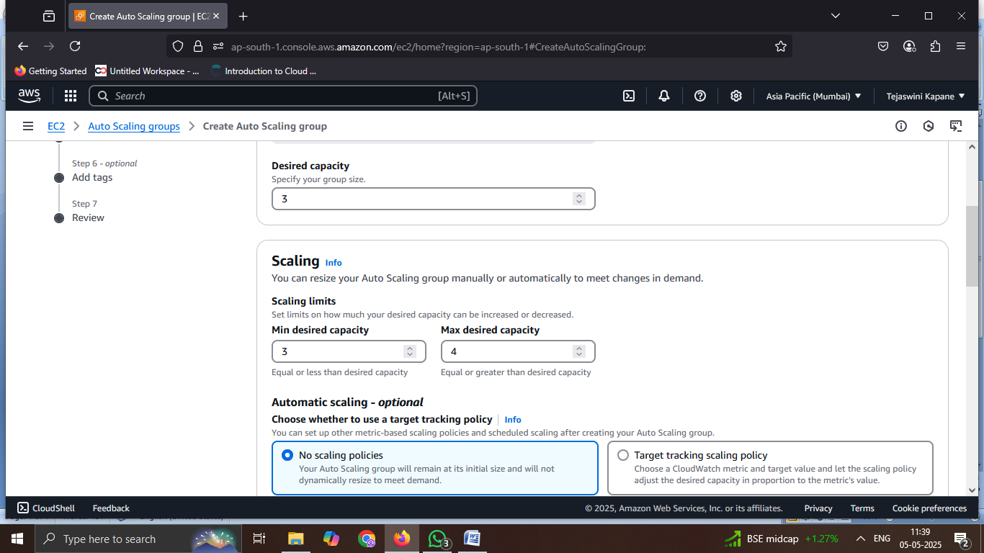

**Step9: Successfully created Auto Scaling Group ‘myautotest’ using the launch template ‘mytemplatetest’ in the AWS EC2 Console**.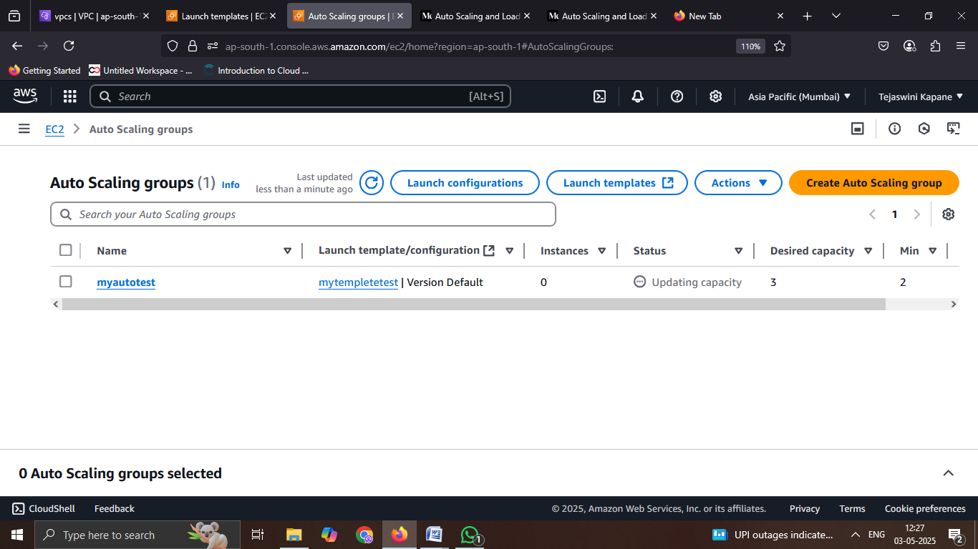

**Step10: Apache web server successfully running on EC2 instances, showing instance status as “Running” and system checks passed in the AWS EC2 Console.**

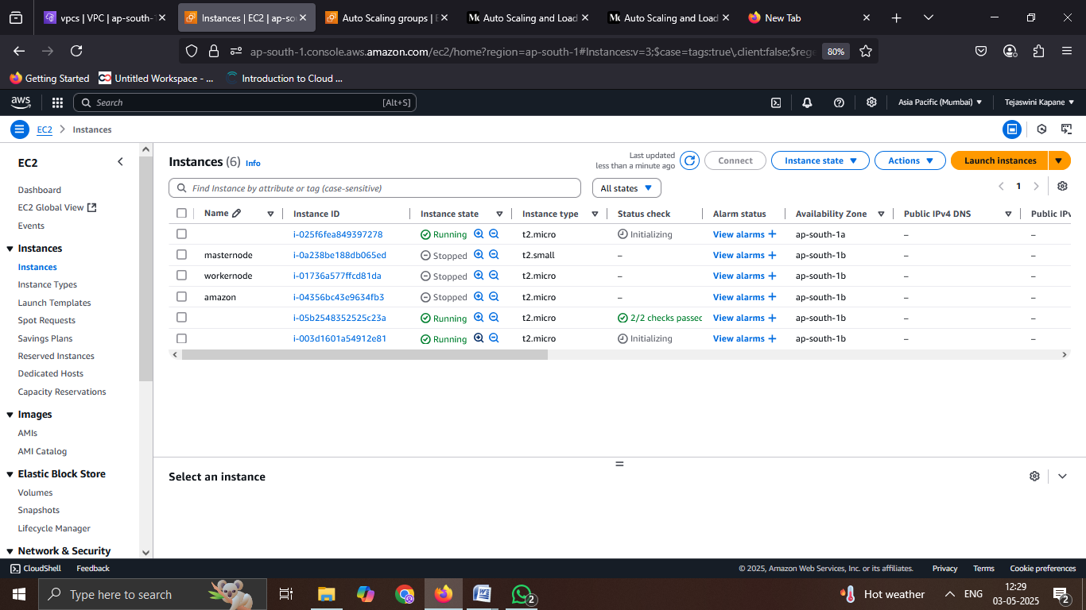

**Step11: Apache web server successfully running and accessible via public IP (65.1.111.139), displaying the internal EC2 hostname (ip-10-0-2-41.ap-south-1.compute.internal) in the browser.**

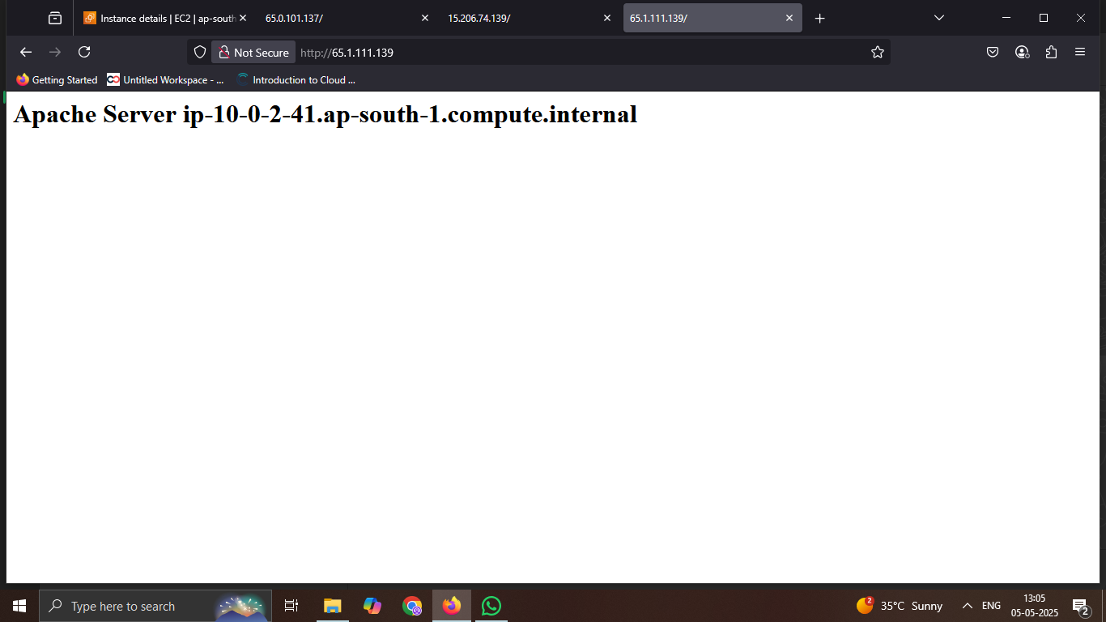

**Step12: Target group nginxgroup successfully created in the AWS EC2 console with instance-based target type, using HTTP protocol on port 80, and currently showing no registered targets.**

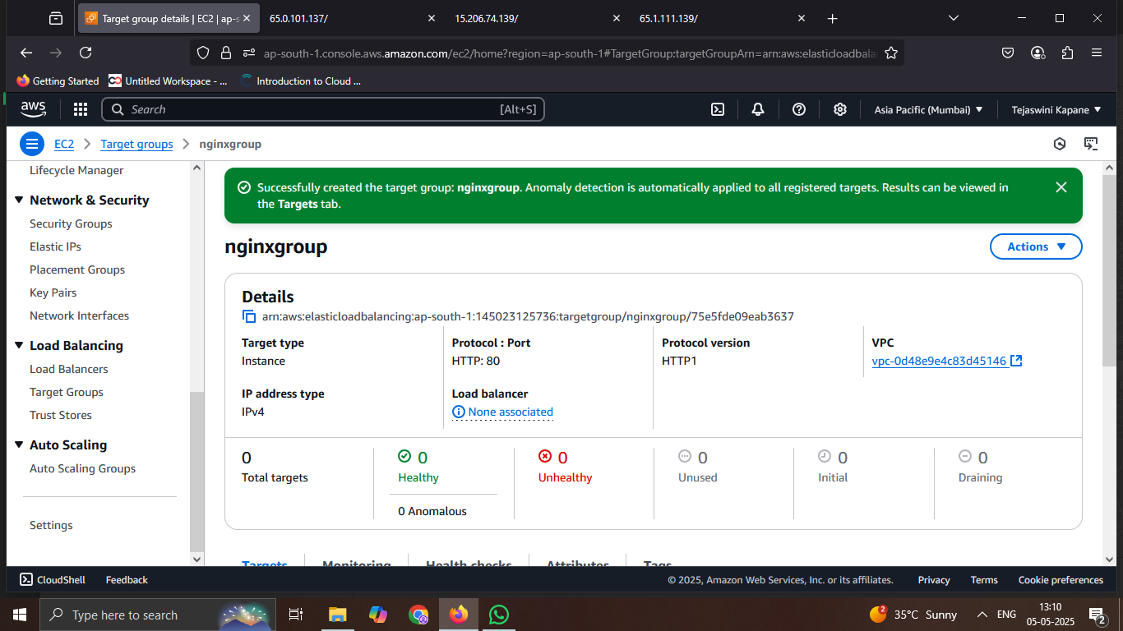

**Step13: Two target groups (mytargettest and nginxgroup) listed in the AWS EC2 console, both configured with HTTP protocol on port 80 and instance target type. The nginxgroup is currently not associated with any load balancer.**

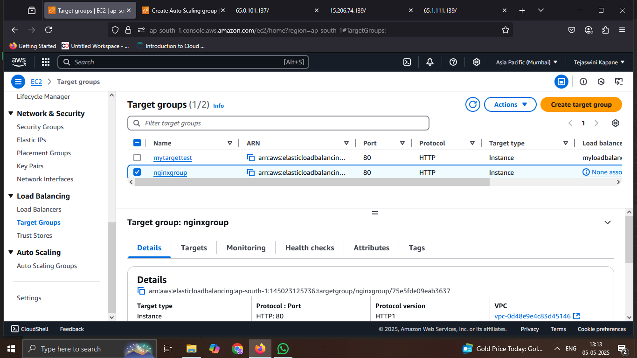

**Step14: The second Auto Scaling group named nginxauto created successfully in the AWS EC2 console, listed alongside an existing group autoscaling1. Both use the same launch template mytesttemplete with different versions.**

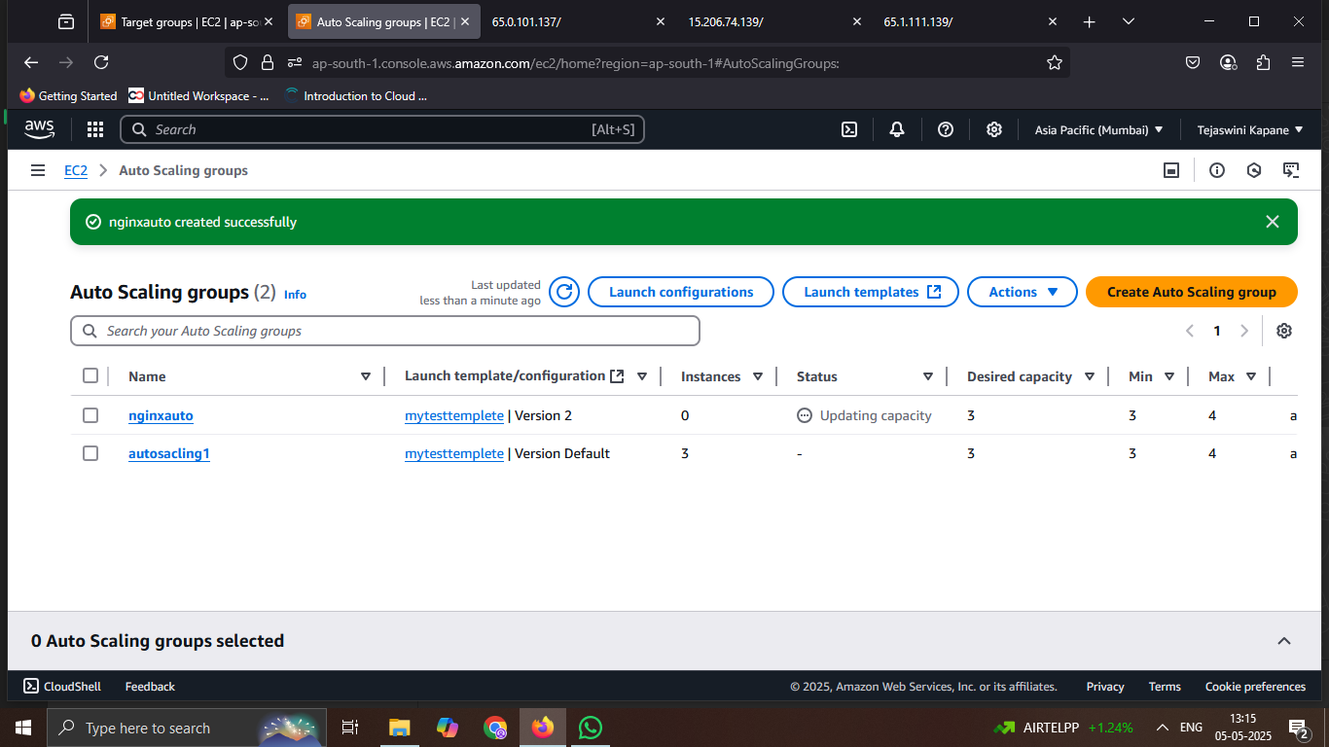

**Step15: EC2 console showing three successfully running NGINX instances (t2.micro) in the 'ap-south-1' region.**

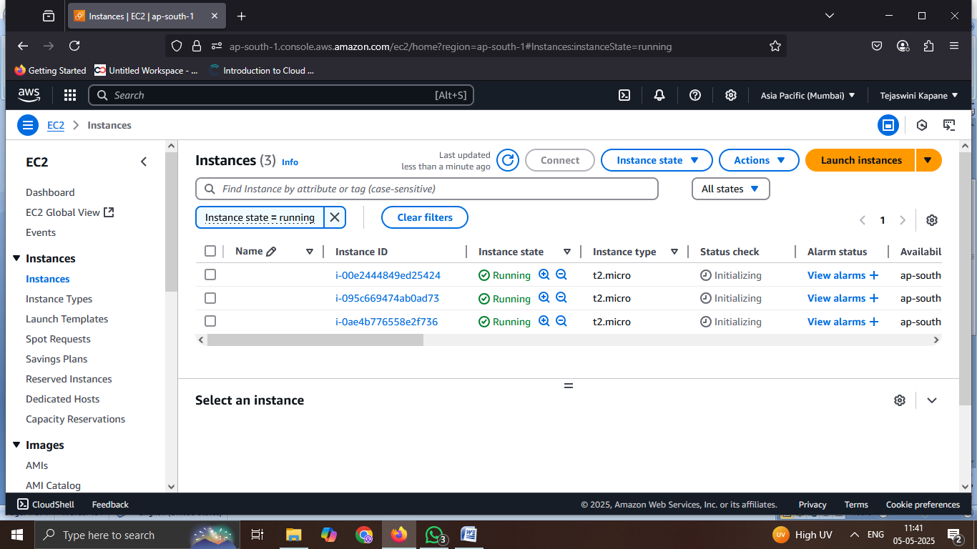

**Step15: Successfully launched and accessed the NGINX web server in a browser**.

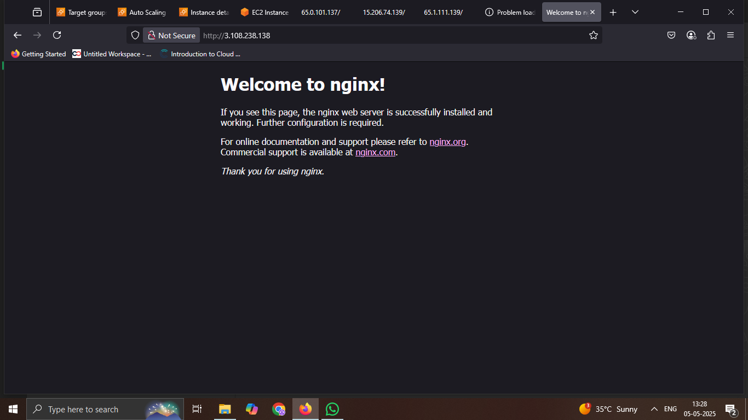

**Step16: Configured load balancer listeners to manage and route incoming traffic to appropriate target groups.**

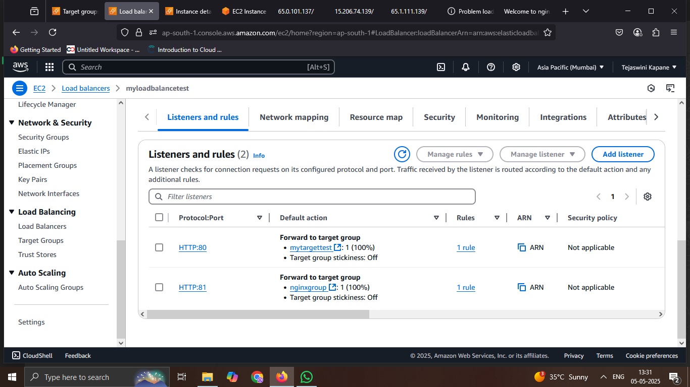

**Step17:** **Load balancer actively distributing traffic based on defined listener rules.**

